PEDIDO DE INSCRIÇÃO

SBB:___________(reservado à ANC) Raça:_______________________________________
Nome:_______________________________________________________________________________________
RP:______________ Sexo: ( ) M ( ) F Data de Nascimento:______/______/__________
Pelagem e Sinais: _______________________________________________________________________________________________________________________________________________________________________________________________________________________________________________________________________________________
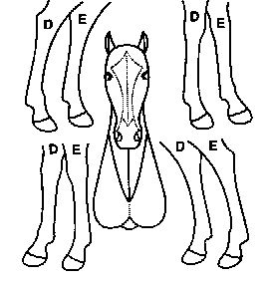

Pai:____________________________________________________________ RP:___________ SBB:__________
Mãe:__________________________________________________________ RP:___________ SBB: __________
Criador:______________________________________________________________________________________
Estabelecimento:_________________________________________________ Município: ____________________

Data:_______/_______/__________

_______________________________________________
(assinatura do criador)

